**Pain relieving interventions for retinopathy of prematurity: Systematic review and network meta-analysis**

Disher, T., Cameron, C., Mitra, S., Cathcart, K., Campbell-Yeo, M.

**Funding:** No study-specific funding to report. Disher is supported by a Canadian Graduate Scholarships Vanier Scholarship, a Killam pre-doctoral scholarship, an NSHRF Scotia Scholar award, a Nova Scotia Graduate Scholarship, and the Electa MacLennan memorial scholarship. Campbell-Yeo is supported by a Canadian Institutes of Health Research (CIHR) New Investigator Award.

**Acknowledgements:** Authors would like to thank Drs. Sofia Dias and Kristian Thorlund for their prompt and helpful assistance in clarifying implications of model code, and assistance in interpretation of heterogeneity. We would also like to thank Mr. Aaron Situ and Cornerstone Research Group for providing R code for league tables and heat plots.

To be submitted to:JAMA Pediatrics

Guidelines:

Maximum length: 3500 words of text (not including abstract, tables, figures, acknowledgments, references, and online-only material), with no more than a total of 4 tables and/or figures and no more than 50-75 references. The subtitle should include the phrase "A Meta-analysis."

**Current word count: 3421/3500**

**Key Points (75-100 words)**

**Question:** What is the most effective pain-relieving treatment for retinopathy of prematurity eye exams in preterm neonates?

**Findings:** This review found that treatments that combine a topical anesthetic with sweet taste and other multisensory interventions (e.g. non-nutritive sucking) were the most likely to be optimal. No treatments appeared effective in absolute terms.

**Meaning:** Combined treatments are likely to offer the best pain relief, but relative efficacy may vary across sites for reasons we could not identify. Future research should focus on identifying novel approaches to pain relief that make larger differences in absolute scores.

Word count: 114

**Abstract**

**Importance:** Despite substantial research effort to identify effective interventionsto reduce pain associated with retinopathy of prematurity eye exams in preterm infants, there has been no systematic review that compares all available interventions.

**Evidence Review:** Systematic review and network meta-analysisMEDLINE, Embase, Cochrane CENTRAL, Web of Science, and the WHO ICTRP (2004-Feb 2017). Interventions intended to provide pain relief that could involve pharmacological, non-pharmacological, multisensory, or procedural modifications (e.g. the use of wide-field digital retina imaging)were included. Abstract and title screen, full-text screening, and data extraction were conducted independently by two reviewers. The primary outcomewaspainduring the exam period (pain reactivity) with pain following the exam (pain regulation) and adverse events as secondary outcomes.

**Results:**Twenty four studies were eligible for inclusion, with 16 studies (N = 966) included in meta-analysis of the primary outcome. Interventions combining a topical anesthetic with sweet taste and an adjunct intervention (e.g. non-nutritive sucking) had the highest probability of being the optimal treatment, but differences between the top two treatments were small (Sweet taste multisensory + topical anesthetic vs. Sweet taste + topical anesthetic mean difference = -0.21; 95% credible interval -2.97 to 2.49). Heterogeneity was moderate in the pain reactivity phase and large in the regulation phase. Secondary outcomes were sparsely reported (2-4 studies, N = 90-248) but generally supported sweet tasting solutions with or without additional adjunct interventions as optimal.

**Conclusions and relevance:**While the benefit is small, the addition of a multisensory intervention to sweet taste and topical anesthetic agents is likely the optimal treatment for reducing pain from eye exams in preterm infants compared to all other interventions. No interventions were effective in absolute terms, with the majority of babies expected to experience moderate to severe pain regardless of intervention. Future research should focus on identifying novel strategies including assessment of whether screening procedures can be modified without sacrificing screening program effectiveness.

**Background**

Retinopathy of prematurity (RoP) is a potentially serious disease that arises from the immature vasculature of the preterm retina3 which if left untreated can result in blindness. Current guidelines recommend that infants born less than 30 weeks receive eye serial eye exams (sometimes as often as weekly) until their retina reach maturity3. This procedure is widely recognized as being painful, with neonates showing both immediate pain behaviors and prolongedphysiological arousal4.RoP examinations are one of many medially indicated painful procedures that preterm neonates endure, with average exposure of up to 12 procedures per day during hospitalization in the Neonatal intensive care unit (NICU)( Cruz, 2016) . This highpain exposurehasbeen associated with numerous short and long-term sequelae including altered cortical development and changes in response to later pain1,2. Thus, determining optimal ways to reduce pain associated with painful medical procedures is of outmost importance in the aim to ensure optimal outcomes for these vulnerable newborns.

Methods to reduce the pain associated with RoP eye examinationinclude pharmacological, non-pharmacological, and procedural modification interventions4. The plurality of approaches makes a direct comparison of all interventions unfeasible without a large multi-centre trial. As a result, despite the topic being the subject of at least three recent reviews4–6, it has not been possible to provide a statistically derived estimate of the most effective treatment. The purpose of this systematic review will be to combine all existing randomized trials of pain-relieving interventions for RoP exams using network meta-analysis to allow for comparison of direct and indirect evidence.

**Objectives**

To conduct a systematic review and network meta-analysis comparing all available pain-relieving strategies for RoP eye examinations.

**Methods**

**Study Design**

Systematic review with Bayesian network meta-analysis using the gemtc package in R for statistics7,8. A pre-specified protocolwas followed (PROSPERO 2017:CRD42017058231).(supplement_)

**Search Strategy and Selection Criteria**

A database search was conducted in July 2017. The search strategy was developed in partnership with a library professional and included searches of the Cochrane Library Central Registry of Controlled Trials (1966-present), MEDLINE (1946-present), Embase (1974-present), and Web of Science (1900-present) (See supplementary material for MEDLINE strategy). Eligible trials designs included randomized clinical trials comparing at least two pain-relieving strategies for ROP eye exams conducted in preterm neonates.

**Study Selection and Data Extraction**

Parallel group and cross-over designs were included. Eligible interventions included those that were intended to provide pain relief and could include pharmacological (e.g. sucrose), non-pharmacological (e.g. non-nutritive sucking), combined interventions, or procedural modifications.

Abstract and title screen, full-text screening, and data extraction were conducted independently by two reviewers using Covidence9. All conflicts were resolved by reviewers and, if necessary, consultation with a third reviewer. Data was extracted using standardized forms.

**Primary Outcome**

Pain as measured by validated pain assessment tools during the first time point measured during the procedure. All tools were converted to a common scale (the premature infant pain profile)10,11. Following the approach outlined in Pillai Riddell et al.’s12 Cochrane review of nonpharmacologic pain relieving interventions in neonates, we selected one timepoint measured during the procedure (pain reactivity), and the first timepoint after completion of the procedure (pain regulation).

**Secondary outcomes**

Pain assessment scales during the regulation phase, physiological response (e.g. heart rate), and adverse events during reactivity and recovery and cry time during the reactivity phase. When multiple adverse events were reported, the most serious were used for meta-analysis.

**Quality Assessment – Risk of Bias**

Critical appraisal was conducted using the Cochrane risk of bias tool for randomized controlled trials13. Two reviewers assessed each study, with conflicts resolved through consultation or, if required, consultation with a third reviewer. We intended to use funnel plots to investigate signs of publication bias, although no comparisons had sufficient studies13.

**Statistical Analysis**

Relevant clinical and study design characteristics were compared between eligible trials to assess acceptability to synthesis. These included infant postmenstrual age at the time of theprocedure, birthweight, use of a speculum and scleral depression during theprocedure, and infant positioning (e.g. swaddled or contained). Network structure was explored through the use of network diagrams. Pairwise andnetwork meta-analysis was conducted using the gemtc8 package in R7.Models properly account for correlation in multi-arm trials, use a single heterogeneity parameter for the entire network, and place vague priors on all parameters14. Model fit was assessed through comparison of residual deviance to the number of unconstrained data points, and deviance information criteria. Fit for meta-regressions were assessed through these characteristics in addition to whether the 95% credible interval (CrI) of the regression coefficient excludes zero15. All analyses were run on four chains with 20,000 iterations a chain including a burn in period of 5000 runs. Convergence was monitored using the Brooks-Gelman-Rubin diagnostic, with values less than 1.05 considered acceptable if consistent with visual inspection of convergence and time series plots14,16.Standard errors for cross-over trials were adjusted by converting paired t-tests to standard error17. Results of continuous outcomes were expressed in mean difference and accompanied with their 95% credible intervals (CrI). Adverse events were expressed as odds ratios (ORs). The surface under the cumulative ranking curve (SUCRA) was used calculated to express the probability that a treatment is optimal18. Results of the largest trial were used to estimate the absolute PIPP reactivity score, and this value was used to convert mean differences to absolute scores for the top three treatments14. Mean absolute scores were used to calculate the number of infants expected with scores indicating low, moderate, and severe pain assuming pain scores are normally distributed.

Heterogeneity was assessed through the standard deviation of the random effect distribution. Assessment of inconsistency within the network (e.g. agreement between direct and indirect evidence) was conducted through the use of a node-splitting model19. Meta-regressions were conducted if potential effect modifiers (e.g. post-menstrual age at time of procedure, risk of bias) showed evidence of variability between studies in addition to showing evidence of interaction with treatment effect. Sensitivity analyses were conducted to test key assumptions related to synthesis feasibility and included use of imputed mean, exclusion of published posters, and exclusion of studies that appear to contribute to inconsistency.

**Results**

**Search results**

The database search returned 831 citations after removal of duplicates, of which 29 studiesmet all inclusion criteria (Supplementary figure 1).

**Study characteristics**

Twenty-threestudies were parallel randomized controlled trials20–41, with six studies42–47reported as randomized crossover trials.Based on consultation with clinicians, interventions were grouped based on hypothesized underlying mechanism of action (supplementary table 1). Studies were similar in infant and procedure characteristics (e.g. use of speculum)(supplementary table 2).

**Risk of bias within studies**

Studies assessing interventions that were easily blinded (e.g. sweet taste, oral acetaminophen) wereconsidered to be at an overall low risk of bias (Supplementary figure 2). Details of sequence generation and allocation concealment were unclear in most studies.

**Publication Bias**

We identified several trial registries indicating trials that are or should realistically be complete without an identifiable publication of results in abstract or manuscript form48–53. One of these was a trial assessing theefficacy of acetaminophen which was stopped early because the intervention showed no effect50. None of the contacts listed responded to e-mails.

**Primary outcome**

Twenty studies (n = 1228) reported results of a validated pain assessment scale during the pain reactivity phase (Fig 1). Two studies were excluded from primary analysis (supplementary table 3). Signs of inconsistency were detected in the non-nutritive sucking node which appeared to arise from a single trial20 that was considered high risk of bias (Supplementary table 4). With this trial excluded, signs of inconsistency resolved and model fit improved, thus remaining regressions and sensitivity analyses were conducted with this trial excluded (Supplementary table 5 and Supplementary figures 2,3).Removal of studies with imputed means resulted in the best model fit, although treatment rankings were similar across all sensitivity analyses (Supplementary figure 4). Relative (Figure 2) and absolute (Figure 3) scores based on the best fitting model suggest small differences between the top treatments (probability of at least 2 point difference = 12.8%), with no interventions lowering mean absolute scores to ranges on the PIPP associated with low or no pain (probability that absolute score is less than six less than 1%).

**Secondary outcomes**

**Pain assessment scales during regulation phase.** Twelve studies assessing eleven interventions (n = 693) were included in the analysis. Meta-regression and sensitivity analyses were unsuccessful in making robust associations between treatment effects and study characteristics (Supplementary figure 5) resulting in wide credible intervals (Supplementary figure 6). Direction and magnitude of effect did not meaningfully change for any model that was a good fit for the data.Combined treatments had a higher probability of being optimal based on SUCRA (Figure 4).Node-splitting models did not detect inconsistency, and manual review of plots did not indicate systematic disagreements between direct and indirect evidence (Supplementary figure 8).

**Heart rate.** Five studies (n = 381) reported heart rate during the reactivity phase, but three were excluded and the remaining studies did not form a connected network (Supplementary table 3). Xin41 reported that sweet taste combined with topical anesthetic was superior to topical anesthetic alone (MD = -23.7bpm, p < 0.01), and SenarTaplak and Erdem37 found no statistically significant difference between non-nutritive sucking (NNS), sweet taste + NNS, or expressed breast milk (EBM) multisensory with topical anesthetic, although mean results favoured NNS alone. Three studies (N = 173) reported heart rate during the regulation phase, but one46 was excluded from meta-analysis (Supplementary table 3) for missing variance info. Relative effects are wide, 95% credible intervals include zero (Supplementary figure 9) and sweet taste in addition to topical anesthetic has the highest SUCRA ranking (Figure 4). There were no closed loops for assessment of inconsistency.

**Oxygen saturation.** Nine studies (N = 595) reported oxygen saturation in the reactivity phase, but six were excluded from analysis or analyzed with adverse events (Supplementary table 3). Sweet taste combined with topical anesthetic ranked highest (Figure 4) with narrow confidence intervals despite limited evidence (Supplementary figure 10). Five studies (N = 243) reported oxygen saturation in the recovery phase, but four were excluded or analyzed with adverse events (Supplementary table 3). Results from the remaining study44 found identical mean oxygen saturation for infants treated with topical anesthetic alone compared with topical anesthetic and sweet taste. There were no closed loops for assessment of inconsistency.

**Crying time.** Eight studies (N = 421) assessed crying time as an outcome. Four29,32,33,46 were excluded from synthesis (supplementary table 3). Strube, Bakal, and Arthur33 found that feeding infants one hour prior to their eye exam reduced cry time reduced to feeding two hours prior (MD = 19%, p = 0.016), and Mehta et al46found no infants cried during the procedure when a speculum was not used, compared to two when one was used and one when wide-field digital retina imaging was used but conducted no statistical tests. Sweet taste multisensory combined with topical anesthetic was ranked as the best treatment (Figure 4), although credible intervals for the mean difference were large and included zero in most comparisons (Supplemental figure 11).

**Adverse events**. Four studies (N = 268) reported one or more adverse events during the reactivity phase (Supplementary table 6). Two studies23,30 could not be included in meta-analysis since treatments did not connect to the network. Dilli23 found no difference in the rate of bradycardia between NNS with topical anesthetic and Sweet multisensory with a topical anesthetic (Supplementary table 3). O’Sullivan found a non-statistically significant difference favouring Sweet taste multisensory in the same comparison.In the NMA results, sweet taste with topical anesthetic had the highest SUCRA, but relative effects against active treatments were wide (Supplementary figure 12). Longer-term adverse events were assessed in three studies26,43,45 (N = 130) with one excluded26 in the final analysis because it did not report outcomes in a way that could be synthesized (Supplementary table 3). SUCRA ranking favoured no treatment (Figure 4), although relative differences between top treatments were small (Supplementary figure 13) with wide credible intervals.

**Discussion**

While most comparisons failed to reach statistical significance, probabilistic results support the hypothesis that engaging more sensory systems likely results in improved pain relief. Rankings were generally robust to sensitivity analyses, which provides some degree of confidence in their findings although all results should be interpreted with caution.

Results must be interpreted within the limitations related to moderate heterogeneity in pain assessment reactivity phase and severe heterogeneity in the regulation phase. Investigation of potential sources of heterogeneity was limited by incomplete procedure reporting. While these factors may explain some additional heterogeneity, it should be noted that this appears to be a consistent problem faced in meta-analysis of pain-relieving interventions in neonates. Two recently updated Cochrane systematic reviews assessed nonpharmacologic12 and skin-to-skin contact54 as interventions for reducing pain associated with commonly performed painful procedures in preterm and term neonates. In both cases, moderate the high heterogeneity was a commonly cited reason for downgrading the level of evidence from combined analysis. No reviews have had success in identifying explanations for this heterogeneity, and thus it is unclear whether it is the result of methodological or clinical heterogeneity.

Absolute scores suggest that no pain treatment is effective in absolute terms. These scores areplaced in comparison to the same interventions used to reduce pain from vaccination, heel lance, or venepuncture where scores in intervention groups are routinely lying within four and six points on the same scale12,54–56. Future research should thus consider whether new trials comparing these interventions are of value when compared to identifying procedure modifications or new treatments that result in more reasonable absolute scores. Of trials included in this review, the lowest absolute scores were observed in a unit that does not use a speculum29, and the only study that assessed the effect of speculum on pain found evidence to support avoiding its use46. We are not the first to suggest that excluding routine use of eye speculum should be considered46,57, and it would appear that the lack of uptake of earlier suggestions may be the result of fear of missed diagnoses58. Practice change in this direction will thus likely require larger trials establishing its ability to reduce pain when the most effective pain relieving interventions are implemented in addition to an assessment of the potential consequences for sensitivity and specificity of diagnosis liklihood. Others have suggested that persistently high raw pain scores suggest that stronger analgesics should be investigated (e.g., opiates)59. One ongoing clinical trial will investigate the use of morphine for pain reduction during aneye exam and use the PIPP and EEG to assess pain59.

**Conclusions**

Despite limitations, there are consistent trends suggesting that the addition of multisensory pain reducing interventions with topical aesthetic results in improved reduction in pain response to eye exams in preterm infant. Small differences in absolute scores between top treatments suggest little evidence to select between them is ?ifefficacy is primary concern. Between study heterogeneity suggests that efficacy in new roll-outsare likely to vary for reasons that cannot be explained. Clinicians should thus be open to the possibility that the best treatment in their unit may vary. Given the less than optimal efficacy of current treatments, future research investigating novel approachesto reduce pain associated with eye exams in preterm infants is imperative.

References

1. Brummelte S, Grunau RE, Chau V, et al. Procedural pain and brain development in premature newborns. *Ann Neurol*. 2012;71(3):385-396. doi:10.1002/ana.22267.

2. Valeri BO, Holsti L, Linhares MBMM. Neonatal Pain and Developmental Outcomes in Children Born Preterm: A Systematic Review. *Clin J Pain*. 2015;31(4):355-362. doi:10.1097/AJP.0000000000000114.

3. Jefferies A, Canadian Paediatric Society: Fetus and Newborn Committee. Retinopathy of prematurity: An update on screening and management. *Paediatr Child Heal*. 2016;21(2):101-104. doi:10.1016/s0031-3955(02)00111-6.

4. Francis K. Evidence-Based Practice Brief What Is Best Practice for Providing Pain Relief During Retinopathy of Prematurity. 2016;16(3):220-228. doi:10.1097/ANC.0000000000000267.

5. Samra H a, McGrath JM. Pain management during retinopathy of prematurity eye examinations: a systematic review. *Adv Neonatal Care*. 2009;9(3):99-110. doi:10.1097/ANC.0b013e3181a68b48.

6. Sun X, Lemyre B, Barrowman N, O’Connor M. Pain management during eye examinations for retinopathy of prematurity in preterm infants: A systematic review. *Acta Paediatr Int J Paediatr*. 2010;99(3):329-334. doi:10.1111/j.1651-2227.2009.01612.x.

7. R Core Team. R: A language and environment for statistical computing. 2015. https://cran.r-project.org/.

8. van Valkenhoef G, Lu G, de Brock B, Hillege H, Ades AE, Welton NJ. Automating network meta-analysis. *Res Synth Methods*. 2012;3(4):285-299. doi:10.1002/jrsm.1054.

9. Veritas Health Innovation. Covidence systematic review software. www.covidence.org.

10. Busse JW, Bartlett SJ, Dougados M, et al. Optimal Strategies for Reporting Pain in Clinical Trials and Systematic Reviews: Recommendations from an OMERACT 12 Workshop. *J Rheumatol*. 2015;42(10):1962-1970. doi:10.3899/jrheum.141440.

11. Thorlund K, Walter SD, Johnston BC, Furukawa TA, Guyatt GH. Pooling health-related quality of life outcomes in meta-analysis-a tutorial and review of methods for enhancing interpretability. *Res Synth Methods*. 2011;2(3):188-203. doi:10.1002/jrsm.46.

12. Pillai Riddell RR, Racine NM, Gennis HG, et al. Non-pharmacological management of infant and young child procedural pain. In: Pillai Riddell RR, ed. *Cochrane Database of Systematic Reviews*. Chichester, UK: John Wiley & Sons, Ltd; 2011:CD006275. doi:10.1002/14651858.CD006275.pub2.

13. Higgins JPT, Altman DG, Gøtzsche PC, et al. The Cochrane Collaboration’s tool for assessing risk of bias in randomised trials. . *Br Med J*. 2011;343:889-893. doi:doi: 10.1136/bmj.d5928.

14. Dias S, Sutton AJ, Ades AE, Welton NJ. Evidence Synthesis for Decision Making 2: A Generalized Linear Modeling Framework for Pairwise and Network Meta-analysis of Randomized Controlled Trials. *Med Decis Mak*. 2013;33(5):607. doi:10.1177/0272989X12458724.

15. Dias S, Welton NJ, Sutton AJ, Ades AE. Evidence Synthesis for Decision Making 3: Subgroups, Meta-Regression, Bias, and Bias-Adjustment. *Med Decis Mak*. 2013;33(5):597-606. doi:10.1177/0272989X13487604.

16. Edition T, Gelman. *Bayesian Data Analysis*. Vol 1542.; 2015. doi:10.1017/CBO9781107415324.004.

17. Higgins JPT, Green S. *Cochrane Handbook for Systematic Reviews of Interventions*. Version 5. The Cochrane Collaboration; 2011. www.cochrane-handbook.org.

18. Salanti G, Ades AE, Ioannidis J. Graphical methods and numerical summaries for presenting results from multiple-treatment meta-analysis: an overview and tutorial. *J Clin Epidemiol*. 2011;64(2):163-171.

19. Dias S, Welton NJ, Sutton AJ, Caldwell DM, Lu G, Ades a E. Evidence synthesis for decision making 4: inconsistency in networks of evidence based on randomized controlled trials. *Med Decis Making*. 2013;33(5):641-656. doi:10.1177/0272989X12455847.

20. Boyle EM, Freer Y, Khan-Orakzai Z, et al. Sucrose and non-nutritive sucking for the relief of pain in screening for retinopathy of prematurity: a randomised controlled trial. *Arch Dis Child Fetal Neonatal Ed*. 2006;91(3):F166-8. doi:10.1136/adc.2005.087668.

21. Cogen MS, Parker JS, Sleep TE, Elsas FJ, Metz THJ, McGwin GJ. Masked trial of topical anesthesia for retinopathy of prematurity eye examinations. *J AAPOS Off Publ Am Assoc Pediatr Ophthalmol Strabismus*. 2011;15(1 PG-45-8):45-48. NS -.

22. da Costa, M.C., Unchalo Eckert, G., Gastal Borges Fortes, B., Borges Fortes Filho, J., Silveira, R., Procianoy R. Coelho de Costa, M. (2013) Oral glucose for pain relief during exam for ROP. *Clin Sci*. 2013;62(2):199-203.

23. Dilli D, Ilarslan NE, Kabatas EU, et al. Oral sucrose and non-nutritive sucking goes some way to reducing pain during retinopathy of prematurity eye examinations. *Acta Paediatr*. 2014;103(2):e76-9. doi:10.1111/apa.12454.

24. Grabska J, Walden P, Lerer T, et al. Can oral sucrose reduce the pain and distress associated with screening for retinopathy of prematurity?. *J Perinatol*. 2005;25(1 PG-33-5):33-35. NS -.

25. Kabatas EU, Dursun A, Beken S, Dilli D, Zenciroglu A, Okumus N. Efficacy of Single Dose Oral Paracetamol in Reducing Pain During Examination for Retinopathy of Prematurity: A Blinded Randomized Controlled Trial. *Indian J Pediatr*. 2016;83(1):22-26. doi:10.1007/s12098-015-1765-8.

26. Mandel R, Ali N, Chen J, Galic IJ, Levesque L. Nitrous oxide analgesia during retinopathy screening: A randomised controlled trial. *Arch Dis Child - Fetal Neonatal Ed*. 2012;97(2):F83-F87. doi:10.1136/adc.2011.210740.

27. Mitchell A, Stevens B, Mungan N, Johnson W, Lobert S, Boss B. Analgesic effects of oral sucrose and pacifier during eye examinations for retinopathy of prematurity. *Pain Manag Nurs*. 2004;5(4 PG-160-8):160-168. NS -.

28. Rosali L, Nesargi S, Mathew S, Vasu U, Rao SP, Bhat S. Efficacy of expressed breast milk in reducing pain during ROP screening - A randomized controlled trial. *J Trop Pediatr*. 2015;61(2):135-138. doi:10.1093/tropej/fmu073.

29. Olsson E, Eriksson M. Oral glucose for pain relief during eye examinations for retinopathy of prematurity. *J Clin Nurs*. 2011;20(7-8-1054-9):1054-1059. NS -.

30. O’Sullivan a, O’Connor M, Brosnahan D, McCreery K, Dempsey EM. Sweeten, soother and swaddle for retinopathy of prematurity screening: a randomised placebo controlled trial. *Arch Dis Child Fetal Neonatal Ed*. 2010;95(6):F419-22. doi:10.1136/adc.2009.180943.

31. Rush R, Rush S, Ighani F, Anderson B, Irwin M, Naqvi M. The effects of comfort care on the pain response in preterm infants undergoing screening for retinopathy of prematurity. *Retina*. 2005;25(1):59-62. doi:10.1097/00006982-200501000-00008.

32. Saunders RA, Miller KW, Hunt HH. Topical anesthesia during infant eye examinations: does it reduce stress?. *Ann Ophthalmol*. 1993;25(12 PG-436-9):436-439. NS -.

33. Strube YNJ, Bakal JA, Arthur BW. Relationship between feeding schedules and gastric distress during retinopathy of prematurity screening eye examinations. *J AAPOS*. 2010;14(4):334-339. doi:10.1016/j.jaapos.2010.05.008.

34. Manjunatha CM, Ibhanesebhor SE, Rennix C, Fisher H, Abara R. Pain control during retinopathy of prematurity screening : double-blind , randomised , placebo-controlled study. *Infant*. 2009;5(5):155-158.

35. Seifi F, Peirovifar A, Mostafa Gharehbaghi M. Comparing the Efficacy of Oral Sucrose and Acetaminophen in Pain Relief for Ophthalmologic Screening of Retinopathy of Prematurity. *Am J Med Sci Med*. 2013;1(2):24-27. doi:10.12691/ajmsm-1-2-2.

36. Zeraati H, Shahinfar J, Vashani HB, Reyhani T. Effect of Multisensory Stimulation on Pain of Eye Examination in Preterm Infants Hossein. *Anesth Pain Med2*. 2016;7(1). doi:10.1007/s12098-012-0945-z.

37. Şener Taplak A, Erdem E. A Comparison of Breast Milk and Sucrose in Reducing Neonatal Pain During Eye Exam for Retinopathy of Prematurity. *Breastfeed Med*. 2017;12(5):bfm.2016.0122. doi:10.1089/bfm.2016.0122.

38. Benzer D, Pehlevan O, Guler K, Gursoy T, Ovali FH, Karateki G. The effect of sucrose on the control of pain secondary to retinopathy of prematurity examination: Randomized controlled trial. *J Perint Med*. 2015;(43).

39. Cullas Ilarslan N, Dilli D, Kabataş EU, et al. Predicting the efficacy of oral sucrose in reducing pain during ophtalmological examination for retinopathy of prematurity: A prospective randomised study. *Arch Dis Child*. 2012;97((Cullas Ilarslan N.; Dilli D.; Beken S.; Aydin B.; Zenciroʇlu A.; Okumuş N.) Neonatology, Dr Sami Ulus Maternity, Childrens Education and Research Hospital, Division of Neonatology, Ankara, Turkey PG-A55):A55. doi:10.1136/archdischild-2012-302724.0190.

40. Ucar S, Varma M, Altan S. The efficacy of non-nutritive sucking and sucrose for the relief of pain during eye examinations for retinopathy of prematurity: A randomised controlled trial. *Arch Dis Child*. 2014;99(PG-A182-a183):A182-a183. doi:10.1136/archdischild-2014-307384.491.

41. Xin C, Qijia Z, Xiao B, Qiao T. Clinical reseach on the effectiveness of oral administration glucose solution for pain relief during screening of retinopathy of prematurity in preterm infants. *Chin J Obs Gyncol Pediatr2*. 16AD;12(4).

42. Dhaliwal CA, Wright E, McIntosh N, Dhaliwal K, Fleck BW. Pain in neonates during screening for retinopathy of prematurity using binocular indirect ophthalmoscopy and wide-field digital retinal imaging: a randomised comparison. *Arch Dis Child Fetal Neonatal Ed*. 2010;95(2 PG-F146-8):F146-8. NS -.

43. Gal P, Kissling GE, Young WO, et al. Efficacy of sucrose to reduce pain in premature infants during eye examinations for retinopathy of prematurity. *Ann Pharmacother*. 2005;39(6 PG-1029-33):1029-1033. NS -.

44. Kleberg A, Warren I, Norman E, et al. Lower stress responses after Newborn Individualized Developmental Care and Assessment Program care during eye screening examinations for retinopathy of prematurity: a randomized study. *Pediatrics*. 2008;121(5 PG-e1267-78):e1267-78. NS -.

45. Marsh VA, Young WO, Dunaway KK, et al. Efficacy of topical anesthetics to reduce pain in premature infants during eye examinations for retinopathy of prematurity. *Ann Pharmacother*. 2005;39(5 PG-829-33):829-833. NS -.

46. Mehta M, Adams GGW, Bunce C, Xing W, Hill M. Pilot study of the systemic effects of three different screening methods used for retinopathy of prematurity. *Early Hum Dev*. 2005;81(4):355-360. doi:10.1016/j.earlhumdev.2004.09.005.

47. Mehta M, Mansfield T, VanderVeen DK. Effect of topical anesthesia and age on pain scores during retinopathy of prematurity screening. *J Perinatol*. 2010;30(11 PG-731-5):731-735. NS -.

48. Benzer D. Swaddle and/or sucrose role in pain control during eye examination. IRCT201422610279N5. ICTRP search portal. Published 2010.

49. Benzer D. Sucrose role in the pain control during eye examination. *IRCT201422610279N4*. 2017:2-3. WHO ICTRP.

50. Bergseng H. Registration and treatment of pain during eye examination of prematurity. NCT01552993. clinicaltrials.gov. Published 2016.

51. Bergseng H. Infant ­ parent Skin ­ to ­ skin Contact During Screening for Retinopathy. NCT02780544. clinicaltrials.gov. Published 2017.

52. Rosseau T. Use of sucrose to relieve pain during eye examination. NCT00161694. clinicaltrials.gov. Published 2008.

53. Cohen A. Proparacaine and mydriatic eye drop. NCT01266824. clinicaltrials.gov. Published 2013.

54. Johnston C, Campbell-Yeo M, Fernandes A, Inglis D, Streiner D, Zee R. Skin-to-skin care for procedural pain in neonates. *Cochrane database Syst Rev*. 2014;1(1):CD008435. doi:10.1002/14651858.CD008435.pub2.

55. Stevens B, Yamada J, Ohlsson A, Haliburton S, Shorkey A. Sucrose for analgesia in newborn infants undergoing painful procedures. In: Yamada J, ed. *Cochrane Database of Systematic Reviews*. Vol 1. Chichester, UK: John Wiley & Sons, Ltd; 2016:CD001069. doi:10.1002/14651858.CD001069.pub5.

56. Shah PS, Herbozo C, Aliwalas LL, Shah VS. Breastfeeding or breast milk for procedural pain in neonates. *Cochrane Database Syst Rev*. 2012;12:CD004950. doi:10.1002/14651858.CD004950.pub3.

57. Kirchner LM, Jeitler VM, Pollak AM, et al. Must screening examinations for retinopathy of prematurity necessarily be painful? *Retina*. 2009;29(5):586-591. doi:10.1097/IAE.0b013e31819a5fb1.

58. Fourmaux E, Isber R, Korobelnik JF. Re: Must screening examinations for retinopathy of prematurity necessarily be painful? 2005:187-188.

59. Slater R, Hartley C, Moultrie F, et al. A blinded randomised placebo-controlled trial investigating the efficacy of morphine analgesia for procedural pain in infants: Trial protocol. *Wellcome open Res*. 2016;1(May):7. doi:10.12688/wellcomeopenres.10005.1.

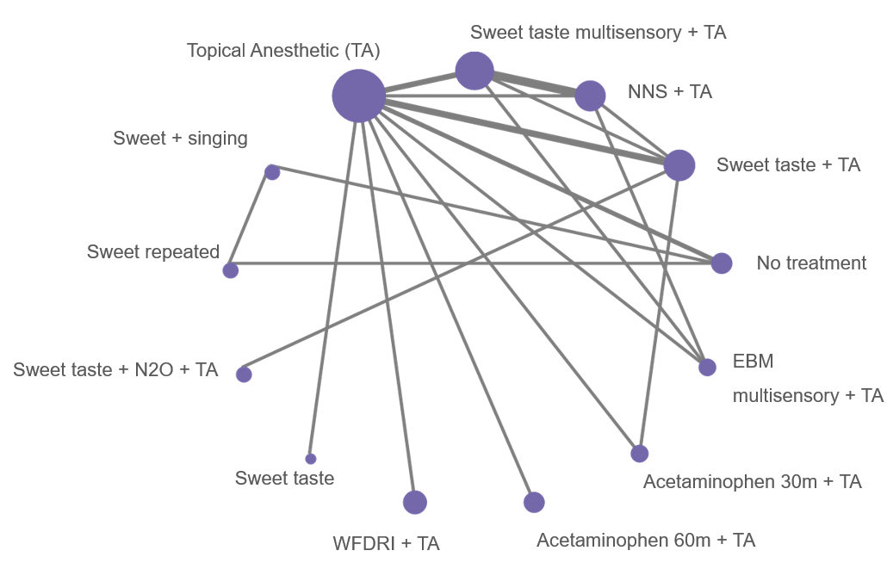

Figure 1. Network graphs for pain reactivity. Nodes indicate treatments and edges indicate comparisons. Size of nodes reflects total sample assessed in a treatment, width of edges indicates number of studies in a comparison.TA = Topical anesthetic; WFDRI = Wide-field digital retina imaging; NNS = Non-nutritive sucking; EBM = Expressed breast milk

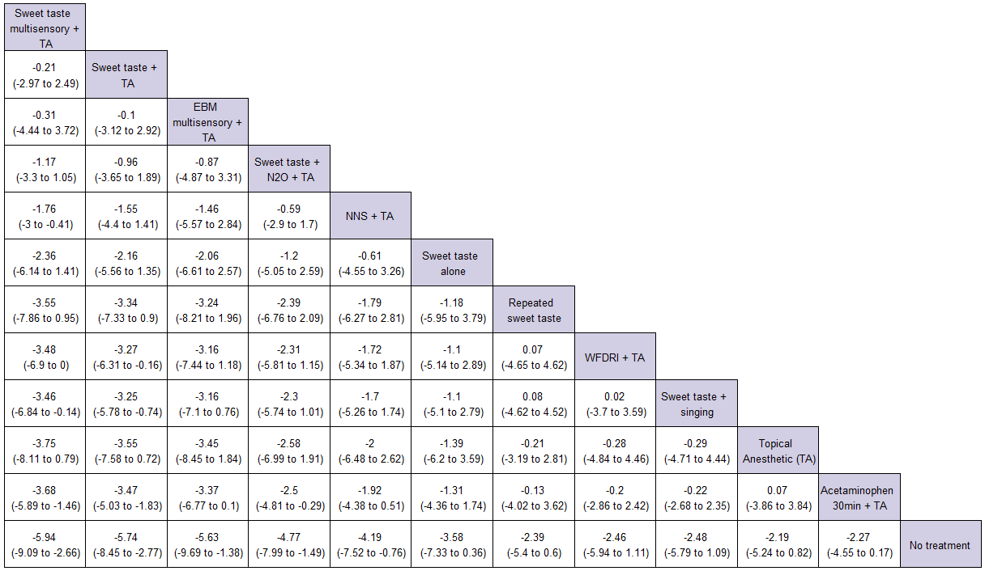

Figure 2. Pain reactivity league table of NMA estimates. Treatments are reported in order of SUCRA ranking. Comparisons should be read left to right with mean differences of less than 0 indicating the treatment in the column is favoured over the treatment in the row. TA = topical anesthetic; NNS = non-nutritive sucking

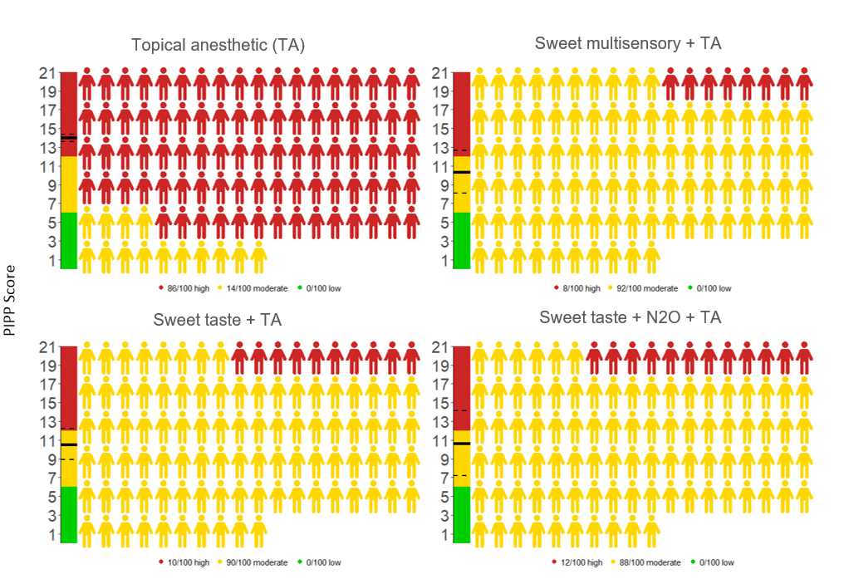

Figure 3. Absolute PIPP scores based on largest low risk of bias trial as baseline (Topical anesthetic). Thermometer indicates absolute score with shading for low (green), moderate (yellow) and severe (red) pain. Solid and dashed line indicates median score with 95% credible interval. Colour of icons indicates the number of neonates expected at each pain threshold using the median score and assuming PIPP scores are normally distributed.

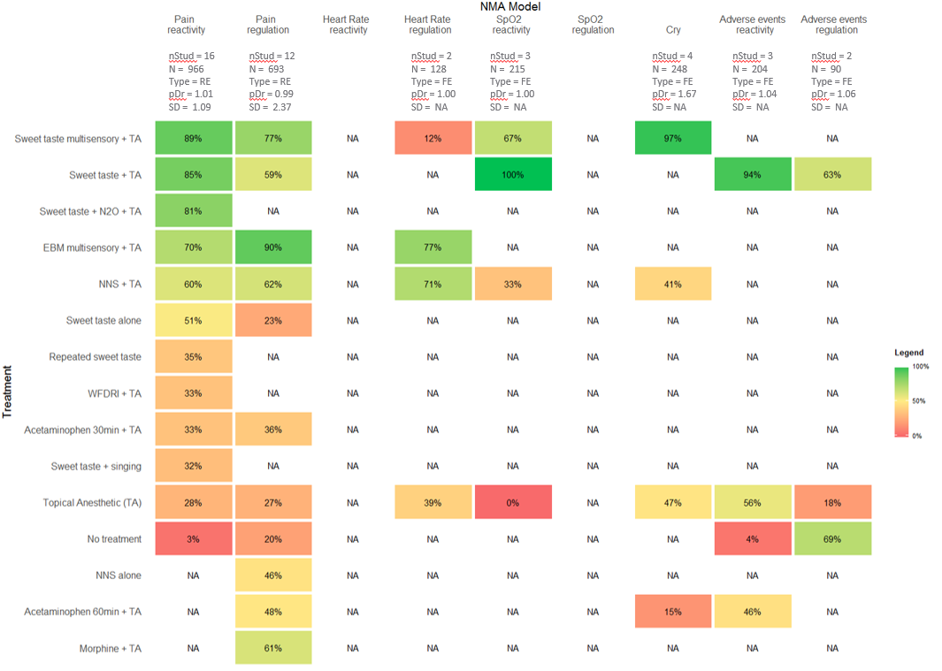

Figure 4. Analyses for all outcome based on SUCRA. Higher scores indicate increased probability that treatment is among the top treatments. SUCRA of 100% indicates treatment is always best, 0% indicates treatment is always worst. NA indicates no information for a treatment. nStud = number of studies; N = total sample size; Type = fixed or random effect model; pDr = Ratio of residual deviance to unconstrained data points; SD = between-trial heterogeneity in units on the PIPP; MR = meta-regression.